INTERNSHIP PROJECT REPORT
ON
TITLE
INFONEXT
Web App

DURATION Of INTERNSHIP
03 September 2024 To 03 March 2025

SUBMITTED BY

Aditya Tanwar
Anjali Bhardwaj
Avneesh Kumar
Bhoomika
Esha Pal
Nikita

SUBMITTED TO:
National Institute of Electronics & Information Technology (NIELIT), Delhi

PROJECT GUIDE
MR NILESH


National Institute of Electronics & Information Technology (NIELIT), Delhi

Acknowledgment

I sincerely express my gratitude to NIELT for providing me with the opportunity to work on the INFONEXT – The Next-Gen Future-Ready Information System Project as a part of my internship. I would also like to thank my supervisor NILESH for their guidance and support throughout the project. Lastly, I extend my thanks to my college/university and all those who directly or indirectly contributed to the successful completion of this project.

Abstract

The INFONEXT Project is designed to streamline and enhance the tracking and management of student and faculty data within the institution. It provides a centralized system for managing academic records, attendance, and performance analytics. The project aims to replace traditional manual tracking methods with a digital solution that improves accessibility, accuracy, and efficiency. It is implemented using the MERN Stack (MongoDB, Express.js, React.js, Node.js) for a seamless user experience and robust backend operations

Table of Contents

- Introduction
- Objectives of the Project
- Technologies Used
- System Architecture
- Implementation Details
- Challenges Faced
- Results and Observations
- Conclusion
- Future Enhancements
- References

Introduction
In the rapidly evolving educational landscape, technology plays a critical role in shaping how students, faculty, and institutions interact with knowledge and resources. Traditional academic management systems often remain fragmented, requiring separate platforms for coding contests, timetables, result tracking, and learning resources. This fragmentation creates inefficiencies, reduces student engagement, and makes it challenging for faculty to manage academic activities effectively.
To address these challenges, INFONEXT has been designed as a comprehensive academic management platform. By integrating multiple functionalities such as coding contests, timetable scheduling, result management, and a centralized course repository into one system, INFONEXT provides a seamless, interactive, and future-ready academic experience.

Purpose:

The primary purpose of INFONEXT is to:
- Create a unified platform where students, faculty, and administrators can access and manage academic resources efficiently.
- Foster student engagement and skill development through competitive programming and real-time performance tracking.
- Provide data-driven insights into student performance, enabling both learners and educators to identify strengths and areas of improvement.
- Promote continuous learning by offering access to trending and categorized events in one centralized hub.
- Facilitate academic events such as bootcamps, technical workshops, and real-time coding contests by providing timely updates, registrations, and participation details directly on the platform.

Objectives
The primary objective of this project is to create an efficient coding contest platform that provides a seamless experience for both participants and organizers. A real-time leaderboard will allow contestants to track their rankings instantly, fostering a competitive and engaging environment. Additionally, the platform aims to simplify timetable scheduling for students and faculty, ensuring automated notifications to keep them updated about upcoming events, exams, or sessions without manual effort.

- To develop a coding contest module with a real-time leaderboard for enhancing students’ problem-solving abilities.
- To create a centralized learning hub featuring trending and categorized courses for continuous skill enhancement.
- To provide admin and creator dashboards for managing contests, schedules, and learning content effectively.
- To build a user-friendly and interactive interface that bridges the gap between students, faculty, and academic opportunities.

Technologies Used

- Frontend: React.js, Web3Form
- Backend: Node.js, Express.js
- Database: MongoDB
- Authentication: JSON Web Token (JWT)
- Styling: CSS/Tailwind/Bootstrap
- API – Postman (for making RestAPIs)

1. Frontend (User Interface & Experience)
- React.js: A powerful JavaScript library for building dynamic and responsive UIs with reusable components.
- Web3Form: A simple, no-backend contact form solution for handling form submissions without server-side code.

2. Backend (Server & Business Logic)
- Node.js: A runtime environment that allows JavaScript to run on the server, enabling fast and scalable backend development.
- Express.js: A lightweight framework for building APIs and handling requests/responses efficiently.

3. Database (Data Storage & Management)
- MongoDB: A NoSQL database that stores data in a flexible, JSON-like format, making it ideal for modern web applications.

4. Authentication (User Security & Access Control)
- JSON Web Token (JWT): A secure method for authenticating users and managing access by issuing encrypted tokens.

5. Styling (UI Design & Responsiveness)
- CSS: Standard styling language for web pages.
- Tailwind CSS: A utility-first CSS framework for rapid, responsive design.

6. API Documentation (Optional, for Better Developer Experience)
- Postman: A tool for generating interactive API documentation, making it easier for developers to understand and test APIs.

Software Development Life Cycle (SDLC)

The Software Development Life Cycle (SDLC) is a structured process that outlines the steps required to develop a high-quality software product. It ensures that the software meets customer requirements, is delivered on time, and functions efficiently. SDLC consists of various phases, each playing a crucial role in software development.

Why SDLC is Important?
✔ Ensures a structured and efficient development process
✔ Reduces project risks and development costs
✔ Improves software quality through continuous testing
✔ Helps deliver a scalable and maintainable product

Agile development

Agile development is a flexible and iterative approach to software development, making it the best choice for INFONEXT. This methodology focuses on continuous development, testing, and user feedback, ensuring that the project evolves smoothly over time. Instead of following a rigid plan, Agile allows developers to build the project in small, manageable iterations called sprints (usually 1-4 weeks long), where new features are developed, tested, and improved based on real-time feedback.

Why Agile is Best for NIELIT InfoTrack?
- Flexible to Changing Requirements – Web applications often require updates, improvements, and new features. Agile allows you to adapt to changes quickly, ensuring that INFONEXT remains relevant and functional.
- Faster Development & Delivery – The project is developed in small, working versions rather than waiting for the entire application to be completed. This means a basic version of NIELIT InfoTrack could be launched early, and new features could be added progressively.
- Continuous User Feedback – Agile ensures that users (students, teachers, and alumni) can provide feedback on early versions of the application, allowing you to make improvements before full deployment.
- Improved Collaboration – Agile promotes teamwork and communication between developers, testers, and stakeholders, leading to better decision-making and high-quality output.
- Bug Fixing & Quality Assurance – Since Agile includes regular testing after each sprint, bugs and issues are identified and resolved early, reducing major technical problems later.

How Agile Works in INFONEXT Development?

- Planning & Requirement Analysis – Identify core features like user registration, profile management, and information tracking.
- Sprint Planning – Break down development into short cycles (sprints) where one set of features is built, tested, and deployed.
- Development & Testing – Each sprint includes coding, testing, and user feedback to improve the application.
- Deployment & Feedback – The working version is deployed, and real-time feedback is used to make further enhancements.
- Iteration & Continuous Improvement – The cycle repeats, adding new features and refining the application based on evolving needs.

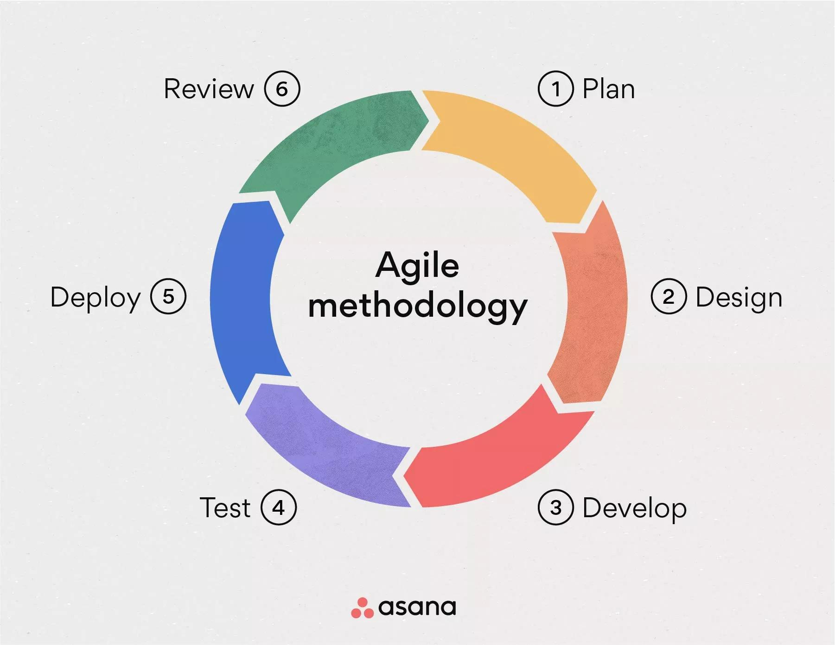

System Features

All Coding Contest
The All Coding Contest feature offers a structured environment for time-bound programming challenges, allowing students to test and enhance their coding skills under competitive conditions. The platform ensures automated code evaluation, providing instant feedback on submissions while maintaining accuracy and fairness. A real-time leaderboard dynamically updates rankings, fostering a competitive spirit among participants. Additionally, the system categorizes problems into different difficulty levels and subjects, implementing a fair scoring mechanism that rewards accuracy, efficiency, and problem-solving skills. This feature helps students improve their logical thinking, coding proficiency, and exam preparedness in a gamified manner.
- Time-bound programming challenges.
- Automated code evaluation and real-time leaderboard.
- Multiple problem categories with a fair scoring system.

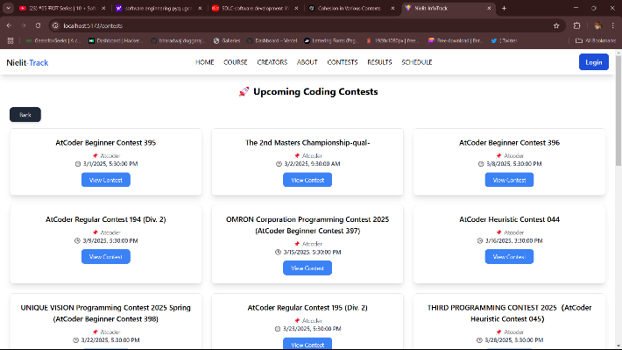

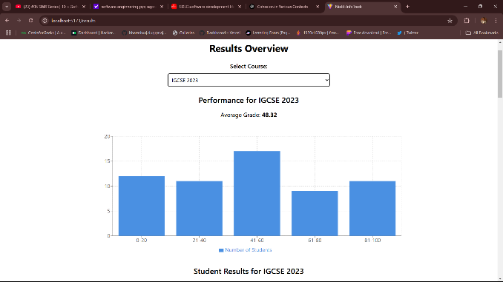

Contact & Support
The Contact & Support system provides a dedicated channel for users to submit inquiries and receive assistance, ensuring quick resolution of any issues or questions. The platform includes a robust admin troubleshooting feature for managing and addressing technical problems, as well as a comprehensive FAQ section that offers answers to common queries, helping users navigate the platform efficiently.
- User inquiry and support system.
- Admin troubleshooting and FAQ section.

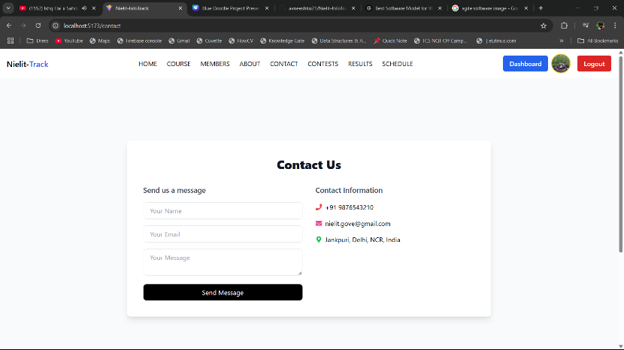

About Us
The About Us section highlights the vision and mission of the platform, outlining its commitment to enhancing academic management and learning experiences. It provides details about the development team, showcasing the expertise and dedication behind the project. Additionally, this section covers the history and objectives of the platform, explaining how it was conceptualized to bridge the gap between students, faculty, and educational resources through technology.
- Vision, mission, and development team details.
- History and objectives of the platform.

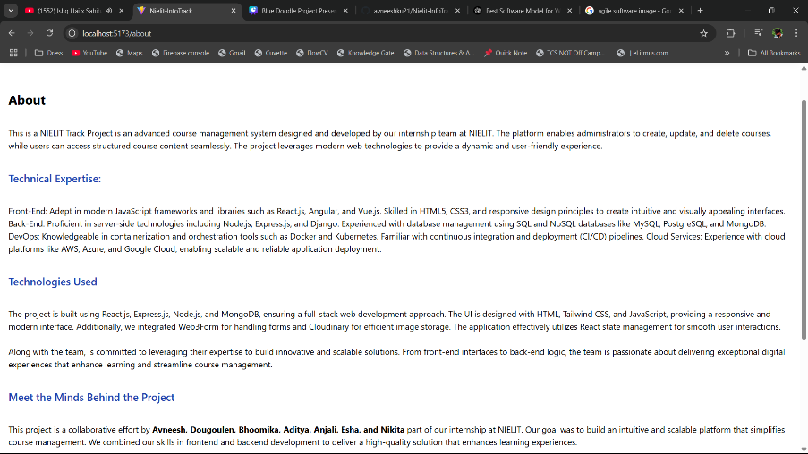

Dashboard for Admin & Faculty Members
The Admin & Creators Dashboard serves as a centralized control panel for managing platform activities efficiently. It includes user management tools, allowing administrators to oversee student and faculty accounts, assign roles, and regulate access. The dashboard also provides performance analytics and reports, offering insights into contest results, academic progress, and engagement trends. These features ensure smooth platform operations, data-driven decision-making, and an improved user experience.
- User management for students and faculty.
- Performance analytics and reports
Trending Events

Trending Events section showcases the latest and most relevant technical activities such as bootcamps, workshops, and seminars, ensuring that students remain engaged with practical and industry-oriented learning opportunities. This feature acts as a bridge between academic knowledge and real-world applications by providing timely updates about upcoming events.
Students can view detailed event information, including the topic, date, duration, and target skill sets. They can also register directly through the platform, making participation seamless and efficient. With integrated notifications, students are always informed about new opportunities to enhance their technical skills and career readiness.

Key Features:
- List of upcoming and trending events such as bootcamps, workshops, and seminars.
- Event details including schedule, description, and skill focus.
- Direct online registration for participation.
- Automated reminders and notifications for upcoming events.
- Post-event access to resources like recordings, slides, or reading material.
All Technical Events
The Technical Events section provides students with access to a wide range of skill-building opportunities, including bootcamps, workshops, and seminars. These events are designed to complement academic learning by focusing on hands-on experience, practical skills, and industry trends.
Events are categorized based on topics, skill level, and objectives, allowing students to choose events that best align with their career goals and interests. Each event listing includes details about the organizers, guest speakers, and learning outcomes, ensuring participants gain maximum value. Registration deadlines and schedules are clearly displayed, helping students plan and participate effectively.
Key Features:
- Comprehensive listing of bootcamps, workshops, and seminars with detailed information.
- Categorized events based on topic, skill level, and objectives.
- Event organizer and speaker profiles with session highlights.
- Clear display of registration deadlines and event schedules.
- Direct online registration and participation tracking.

Implementation Details

The project is built using the MERN Stack architecture, ensuring a scalable, efficient, and modern web application. The frontend is developed with React.js, which provides a dynamic and interactive user interface, enhancing the overall user experience. On the backend, Node.js and Express.js manage the server-side logic, handling user requests, database interactions, and business operations efficiently. Data is stored securely in MongoDB, a flexible NoSQL database that allows seamless handling of structured and unstructured data.

To ensure secure authentication and data privacy, JSON Web Token (JWT) is implemented, enabling token-based user authentication and preventing unauthorized access. For a responsive and visually appealing UI, the project uses Tailwind CSS, which allows rapid design customization while maintaining a clean and professional look.

One of the key features, All Coding Contest, is integrated with Contest Hive, a platform that provides real-time competitive programming challenges. This integration ensures that users can participate in coding contests with automated evaluations, real-time leaderboards, and problem-solving analytics, making the experience engaging and competitive. By leveraging this technology stack, the project delivers a robust, user-friendly, and efficient academic management system.

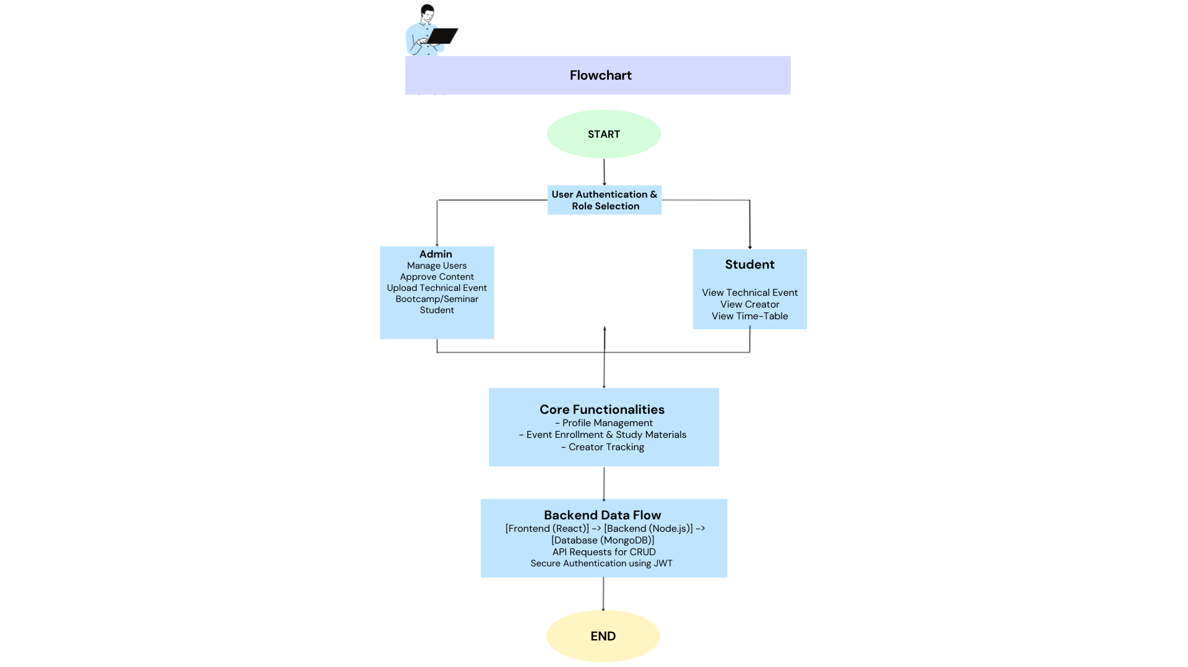

Challenges Faced
During development, several challenges were encountered. Scalability issues arose as the platform needed to efficiently handle a growing number of users and educational content while maintaining performance. Real-time leaderboard tracking required performance optimization to ensure smooth updates without delays. Additionally, security concerns were a major focus, leading to the implementation of robust authentication mechanisms using JWT to protect user data and prevent unauthorized access.
- Scalability Issues: Managing a growing number of users and content efficiently.
- Performance Optimization: Ensuring smooth real-time leaderboard tracking.
- Security Concerns: Implementing robust authentication mechanisms.

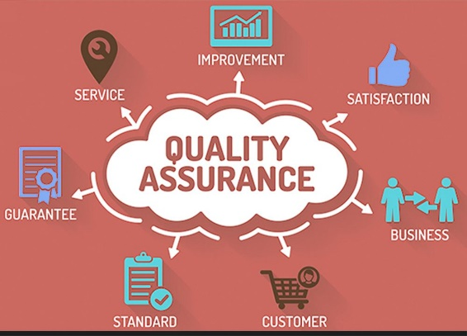

Future Enhancements
To further enhance the platform, several improvements are planned. AI-based performance tracking will be integrated to provide personalized learning recommendations, helping students focus on areas that need improvement. Additionally, a mobile application will be developed to ensure greater accessibility, allowing users to engage with the platform anytime, anywhere. To boost student engagement, gamification features such as badges, rewards, and challenges will be introduced, making learning more interactive and motivating. These enhancements will contribute to a more adaptive, user-friendly, and engaging educational experience.
- Integration of AI-based performance tracking for personalized learning recommendations.
- Gamification features to increase student engagement in learning activities.

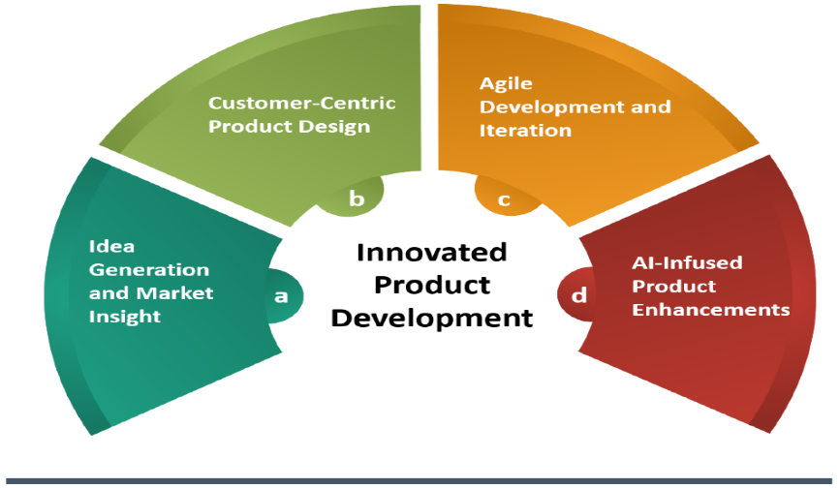

Conclusion
The INFONEXT platform has been developed as a comprehensive academic management system that seamlessly integrates learning, administration, and technical engagement into a single, user-friendly interface. By incorporating features such as coding contests and technical events like bootcamps and seminars, the platform creates a structured and interactive environment for students, faculty, and administrators.
With the implementation of secure authentication, real-time leaderboards, and centralized dashboards, INFONEXT ensures a seamless and engaging user experience. Beyond its core functionality, the platform has also been a valuable learning journey, providing hands-on exposure to full-stack development, database management, scalability, and performance optimization.
Looking ahead, the platform holds immense potential for growth with planned enhancements such as AI-driven recommendations, mobile accessibility, and gamification. These innovations will further personalize the learning experience, making education more accessible, innovative, and impactful for the academic community.

References

Technology Documentation & Official Guides
- React.js Documentation: https://react.dev
- Node.js & Express.js Documentation: https://nodejs.org | https://expressjs.com
- MongoDB Documentation: https://www.mongodb.com/docs/
- JSON Web Token (JWT) Guide: https://jwt.io/introduction
- Tailwind CSS Documentation: https://tailwindcss.com/docs
Competitive Programming Integration
- Contest Hive (Real-time leaderboard & coding contest integration): https://contest-hive.vercel.app/
API Documentation & Best Practices
- Swagger API Documentation: https://swagger.io/docs/
Authentication & Security
- OWASP Security Guidelines: https://owasp.org/www-project-top-ten/
General Learning Resources
- Full-Stack Web Development with MERN Stack (YouTube & Udemy Courses)
- MDN Web Docs for Frontend & Backend Development: https://developer.mozilla.org/
- GitHub Repositories & Open-Source Projects for reference implementations.

